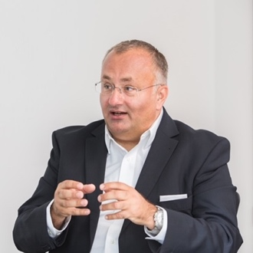

DINKO EROR
BOARD MEMBER | LEADER | NETWORKER
Frankfurt, Germany / email: dinko.eror@gmail.com / Phone: +491705653243

Dinko is a leader with a clear vision for how modern digital business solutions can transform business models. In more than 25 years he has gained a solid reputation for delivering efficiencies and best in class results by disrupting and revolutionizing business through Technology, Cloud, Software, IoT and Artificial Intelligence.
He has led turnarounds and expansions, driving the changes required to accelerate growth and create value in complex global businesses. He is a strategic planner and believes that teamwork combined with business analytics and clear performance objectives generate operational efficiencies, as well as improved business and financial results.
Dinko has held various leadership positions in four big global US companies as well as serving on the boards of German mid-sized companies and startups, where he developed extensive corporate governance expertise.
Currently he is the Global COO for Matrix42, a leading Software Company for digital Workspace, Business and Cloud solutions, having led its transformation from a perpetual license model to becoming a global leader in Software as a Service (SaaS). Most recently he also delivered a number of mergers & acquisitions, buying and fully integrating 3 software companies from USA, Russia and Germany within 18 months. In addition, Dinko prepared and executed a very successful Investor Change (Exit) and restructuring of the company.

Until 2020, he held various international leadership positions at Dell Technologies for more than 10 years:

- CEO of Dell Germany, making Dell the market leader in Germany
- Senior Vice President of EMC2 Global Services for the EMEA region
- Board Member of the EDS & HP EMEA organization

Dinko is a charismatic leader helping people to reach their goals, and he is not afraid to hire people that might be better than him. Adept at recruiting, retaining and inspiring staff members, he has built high-performing and diverse teams and talent pipelines, including the next generation leadership. Dinko enjoys to lead complex organizations in the new digital era and to run bright groups of teams, from sales & marketing to technology and service-oriented organizations to administrative areas, such as HR, Legal or Procurement.
He is a sought-after public speaker, well connected across many industries having participated several times at the World Economic Forum (WEF) Davos as well as joining a number of country visits of the German Government economic delegations.
Dinko was a Board Member of the American Chamber of Commerce and German IT Association BITKOM and is ranked as the 25th cloud influencer in the world by Onalytica. Since more than 15 years he is also serving as an Associate Professor of IT Management for Economic Informatics Students in Mannheim to develop the next generation of digitally savvy leaders.

